

MILESTONE TWO

Group 6. TUES-18:30-2

Mladenov, Nicholas (s3539747)

Giorady, Muhammad Fathur (s3737757)

Duong, Thanh (s3601172)

Abenayake, Gihan (s3779792)

COSC2299 - Software Engineering Processing Tools

**SEMESTER TWO 2020**

**Submitted to**

Lawrence Cavedon

**CONTRIBUTION**

Duong, Thanh (S3601172) 25%:

* SEPT-15
* SEPT-20
* SEPT-22
* SEPT-23
* SEPT-24
* SEPT-35
* SEPT-45
* SEPT-46
* SEPT-49

Abenayake, Gihan (s3779792) 25%:

* Product Backlog Grooming
* SEPT-53
* Meeting Minutes
* Conversation Backlog exporting
* User Story management for sprints, Ie. Context, Constraints, Scenarios and Criterions
* General Organisation

Giorady, Muhammad Fathur (s3737757) 25%:

* SEPT-33
* SEPT-32
* SEPT-33
* SEPT-67
* SEPT-71
* SEPT-74
* SEPT-75
* SEPT-78

Mladenov, Nicholas (s3539747) 25%:

* SEPT-1
* SEPT-2
* SEPT-10
* SEPT-12
* SEPT-13
* SEPT-15
* SEPT-16
* SEPT-17
* SEPT-36
* SEPT-41
* SEPT-42
* SEPT-43
* SEPT-44
* SEPT-47
* SEPT-50
* SEPT-58
* SEPT-59
* SEPT-62
* SEPT-63
* SEPT-64
* SEPT-69
* SEPT-73
* SEPT-77
* SEPT-82
* SEPT-83

SCREENSHOTS

*Larger versions are present in the docs folder

Homepage

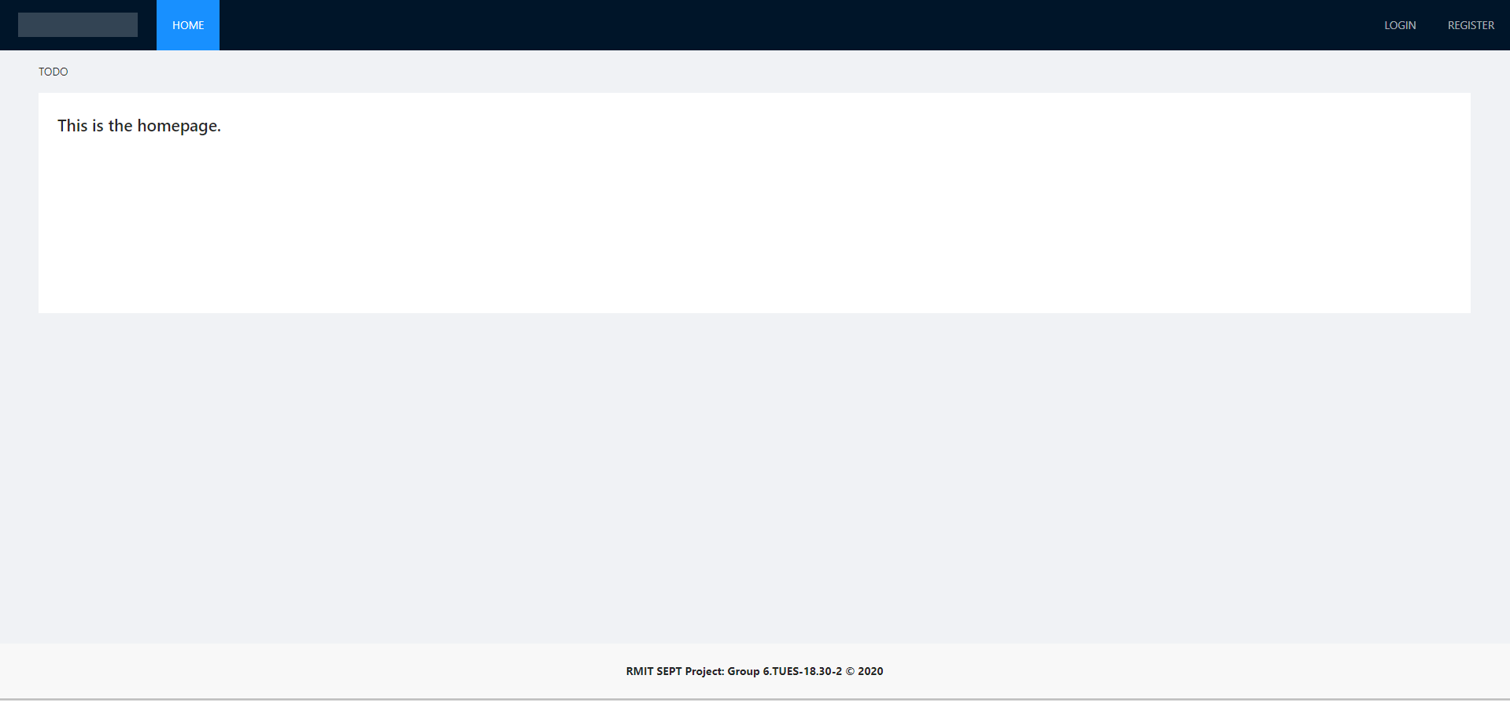

Login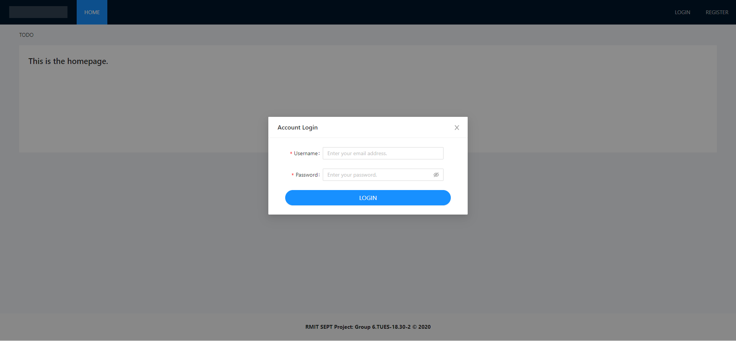

Profile

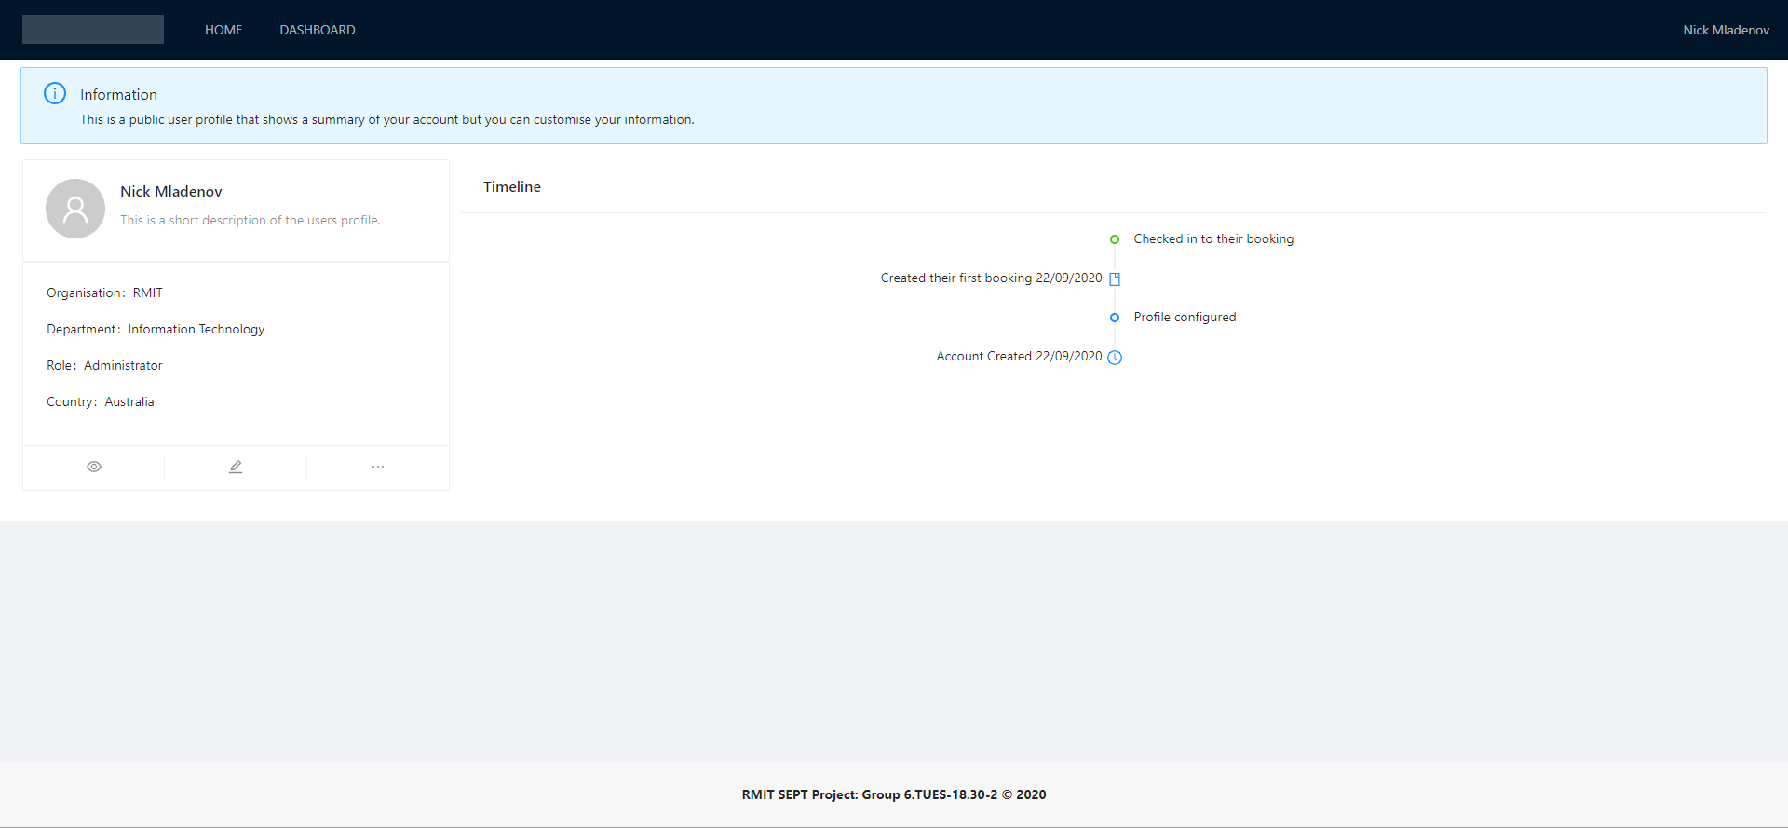

Dashboard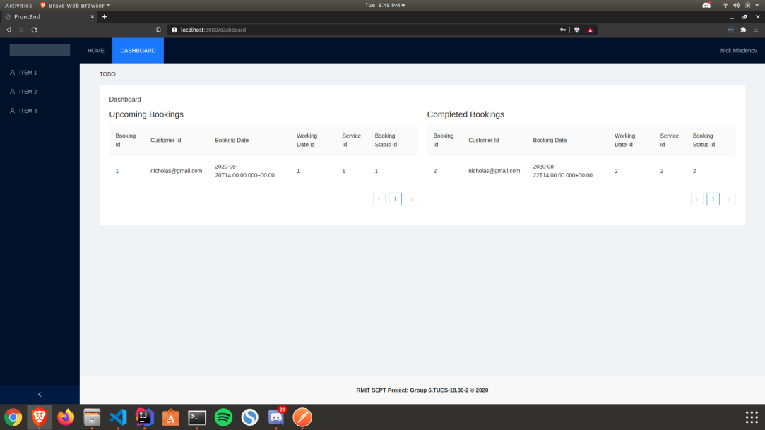

**LINKS AND RESOURCES**

Github

<https://github.com/RMIT-SEPT/majorproject-6-tues-18-30-2>

Jira

<https://s3737757.atlassian.net/jira/software/projects/G6T132/boards/1>

Database Schema v.3

<https://liveuml.com/view/5f51496e5a97dc06484a2546>

Website Wireframe v.1:

<https://app.lucidchart.com/invitations/accept/6e87cc96-f1b3-42ff-9bd1-69c2fff48973>

WEBSITE LINKS

Website Link (Note: Run by Nicholas (**s3539747**))

http://sept.mladenov.me/

PIPELINE LINKS

Website Pipeline:

<https://dev.azure.com/s3539747/SEPT/_build?definitionId=1>

Registration Pipeline:

<https://dev.azure.com/s3539747/SEPT/_build?definitionId=3>

Authentication Pipeline

<https://dev.azure.com/s3539747/SEPT/_build?definitionId=2>

Dashboard Pipeline

<https://dev.azure.com/s3539747/SEPT/_build?definitionId=4>

User Profile Pipeline

<https://dev.azure.com/s3539747/SEPT/_build?definitionId=5>

TESTING LINKS

*Larger images in docs folder

Registration

<https://dev.azure.com/s3539747/SEPT/_build/results?buildId=56&view=ms.vss-test-web.build-test-results-tab>

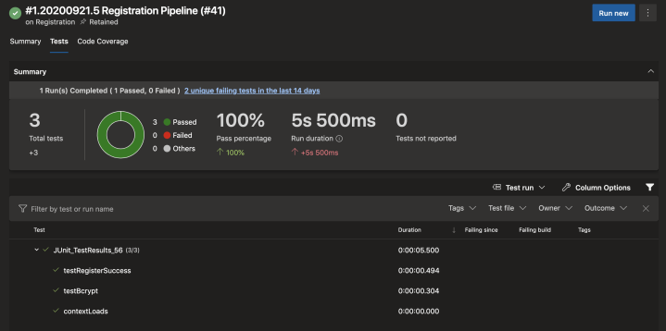

Authentication

<https://dev.azure.com/s3539747/SEPT/_build/results?buildId=44&view=ms.vss-test-web.build-test-results-tab>

Authentication Unauthorized user testing: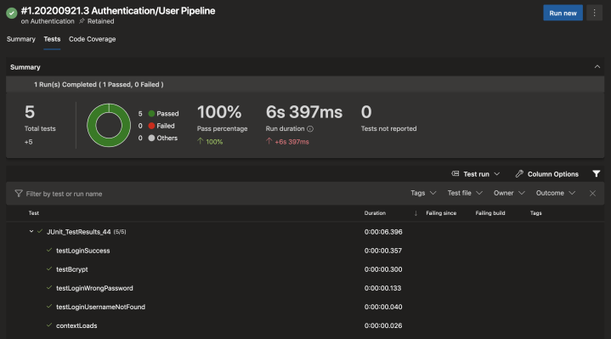

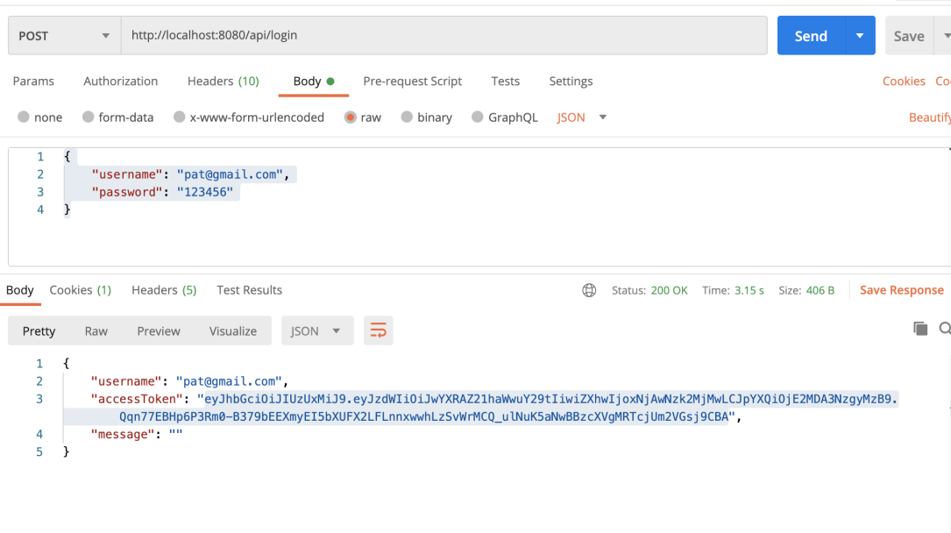

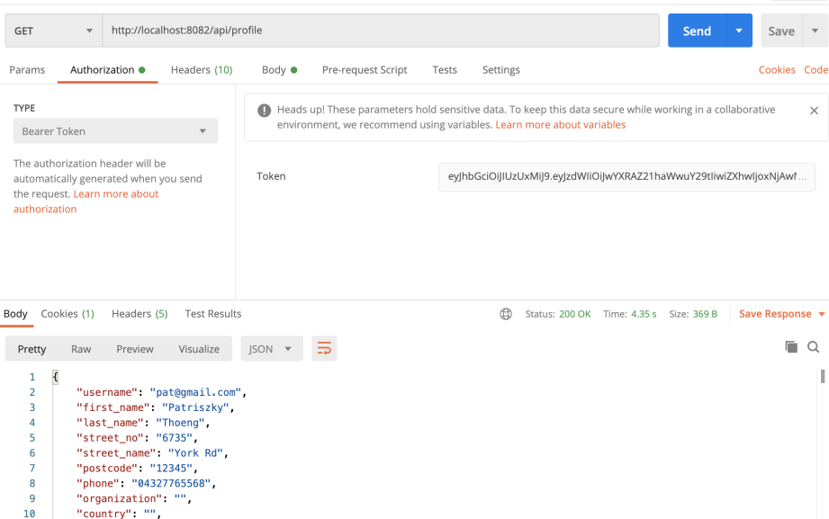

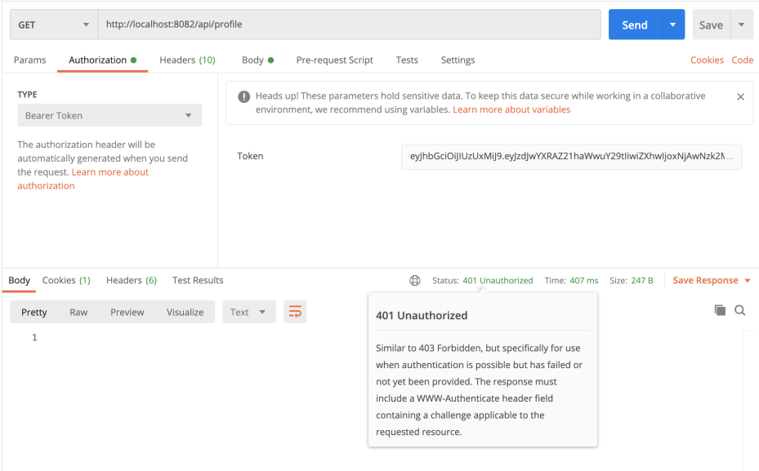

Website**:**

[**https://dev.azure.com/s3539747/SEPT/_build/results?buildId=63&view=ms.vss-test-web.build-test-results-tab**](https://dev.azure.com/s3539747/SEPT/_build/results?buildId=63&view=ms.vss-test-web.build-test-results-tab)

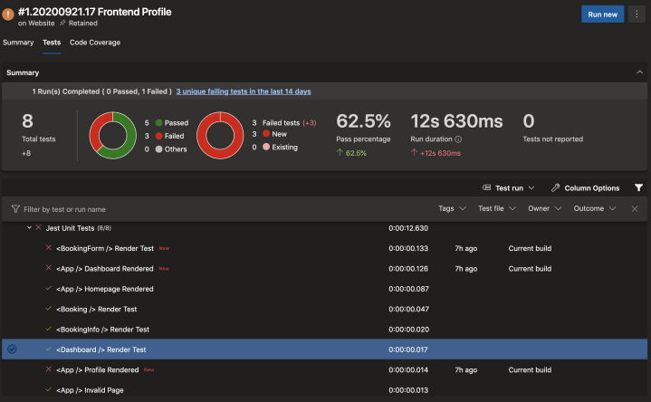

Dashboard

<https://dev.azure.com/s3539747/SEPT/_build/results?buildId=124&view=results>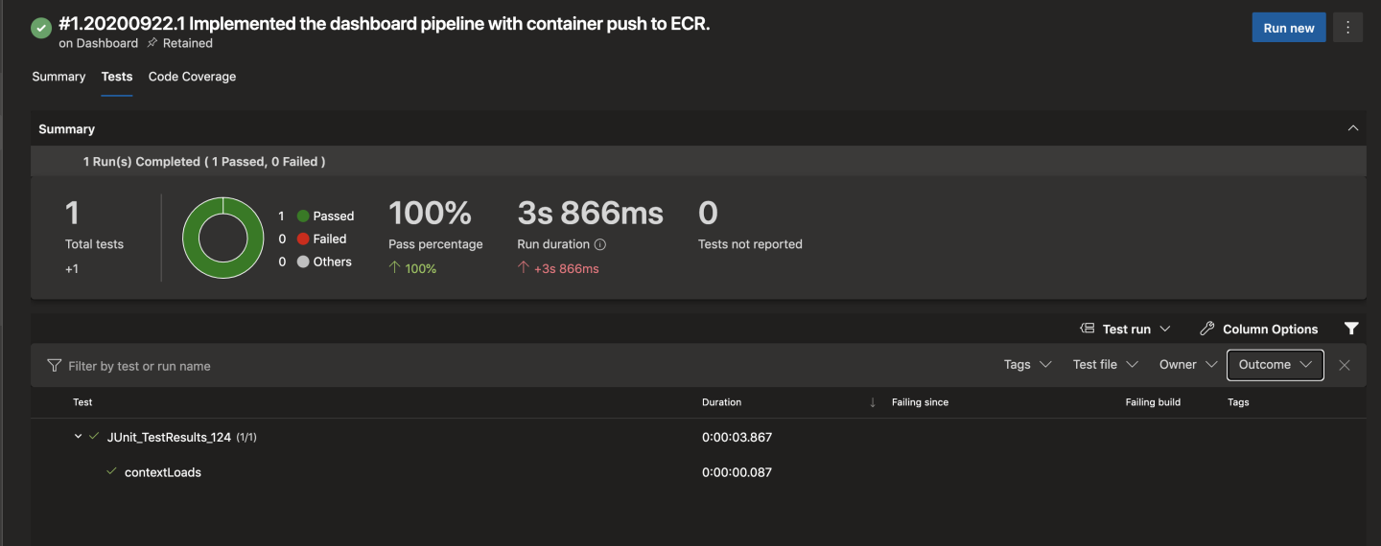

User Profile

<https://dev.azure.com/s3539747/SEPT/_build/results?buildId=141&view=ms.vss-test-web.build-test-results-tab>

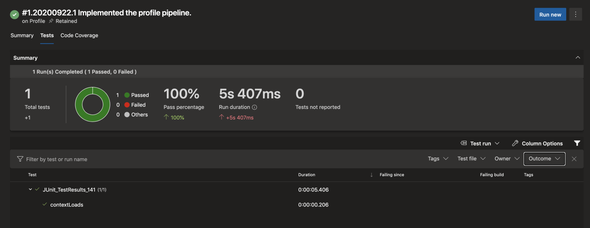

Apps running

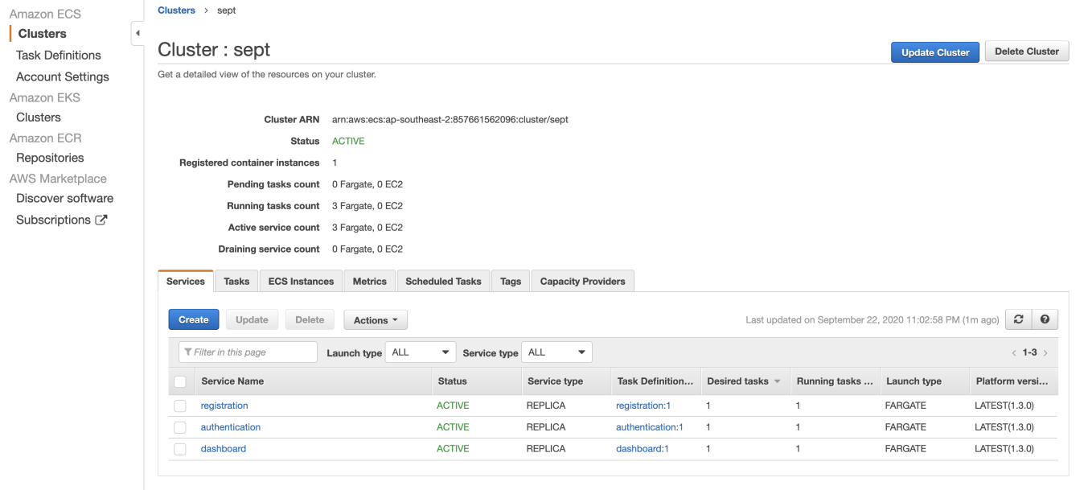

*Please note that communication done with the team and product owner is done via Microsoft Teams and team communication is done via a private Discord server. Chat-logs have been provided for proof.*